**Assignment 7.2**

* Create database Olympics;
* Use Olympics;
* create table olympic (athelete STRING,age INT,country STRING,year STRING,closing STRING,sport STRING,gold INT,silver INT,bronze INT,total INT) row format delimited fields terminated by ‘\t’ stored as textfile;
* load data local inpath ‘/home/acadgild/Downloads/olympic_data.csv’ into table olympic;

**(Refer Screenshots 7.2_createdb, createtable, load)**

1. **Write a Hive program to find the number of medals won by each country in swimming.**

Sol:

select country,SUM(total) from olympic where sport = “Swimming” GROUP BY country;

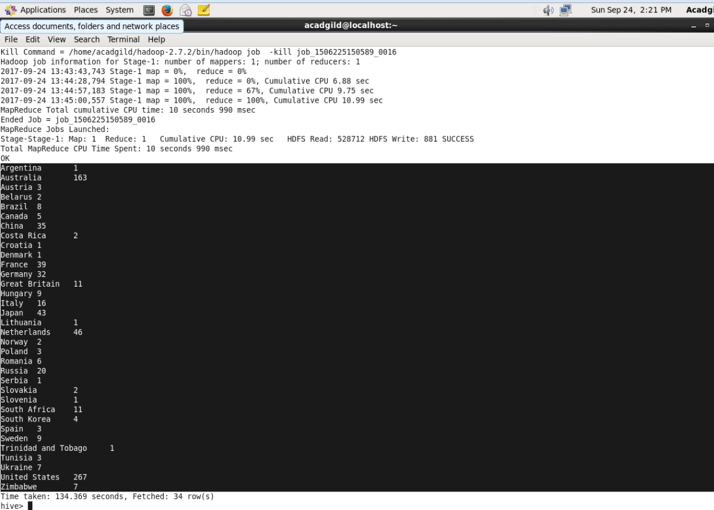

1. **Write a Hive program to find the number of medals that India won year wise.**

Sol: select year,SUM(total) from olympic where country = “India” GROUP BY year;

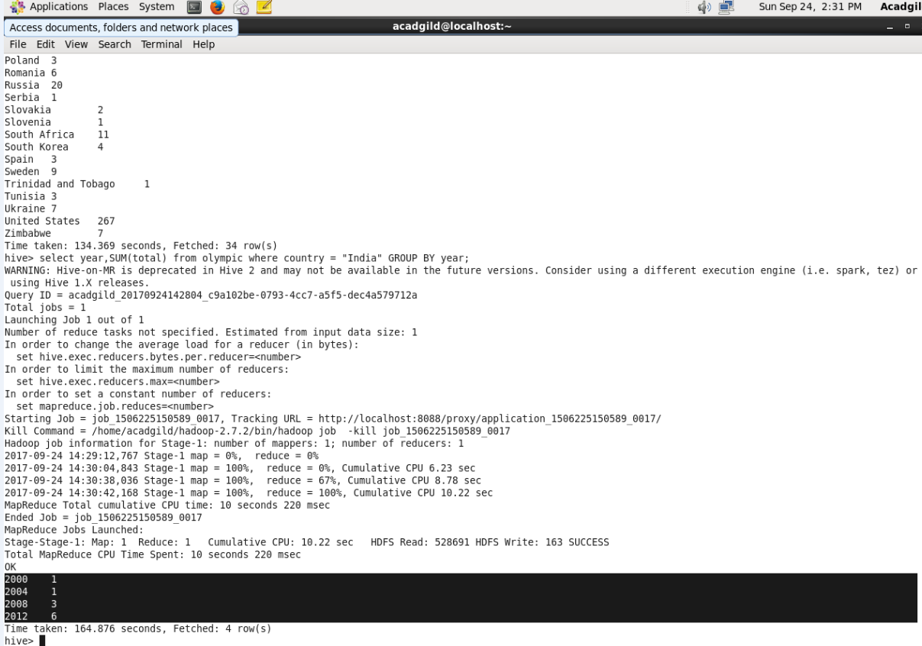

1. **Write a Hive Program to find the total number of medals each country won.**

Sol: select country,SUM(total) from olympic GROUP BY country;

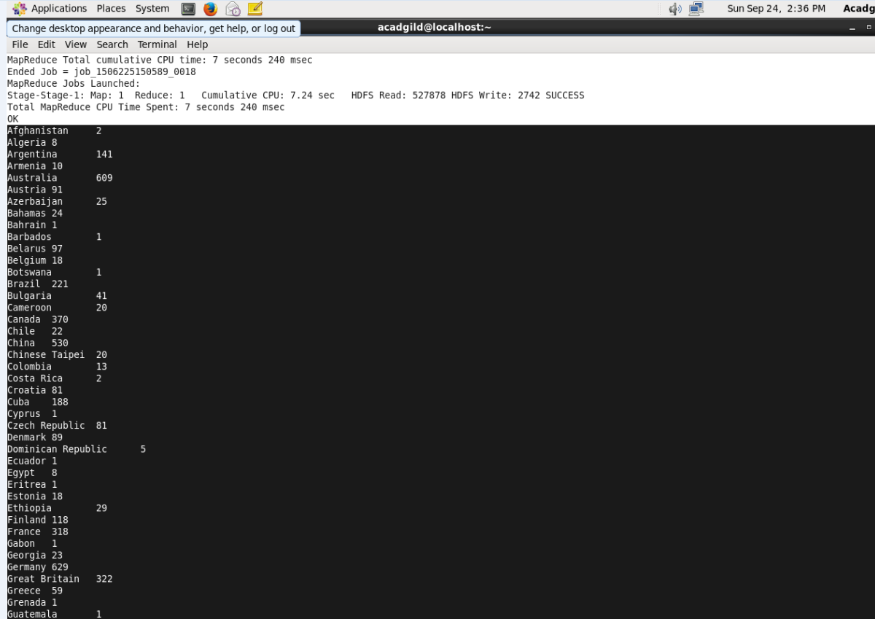

1. **Write a Hive program to find the number of gold medals each country won**

Sol: select country,SUM(gold) from olympic GROUP BY country;

